Employee Attrition

&

Performance Analysis

|  |  |
| --- | --- |
| Internship Project Title | Employee Attrition & Performance Analysis |
| Name of the Company | TCS ion |
| Name of the Industry Mentor | Harish Kumar |
| Name of the Institute | ICT Academy of Kerala |

|  |  |  |  |  |  |  |
| --- | --- | --- | --- | --- | --- | --- |
| Start Date | End Date | | Total Effort (hrs.) | | Project Environment | Tools used |
| 22 March 2023 | 20 April 2023 | |  | | Microsoft | Power BI |
| Milestone # | 1 | Milestone: | | Analyze dataset and identify driving factors related to analytics. | | |

**TABLE OF CONTENT**

* Acknowledgements
* Objective
* Introduction / Description of Internship
* Internship Activities
* Charts, Table, Diagrams
* Challenges & Opportunities
* Reflections on the Internship
* Outcome / Conclusion
* Link to code and executable file

**ACKNOWLEDGEMENTS**

I am grateful to all of those who have helped me to work during internship. I thank ICT Academy of Kerala and TCS ion for providing me such a great opportunity. I extend my gratitude to my industry mentor Mr. Harish Kumar and Miss Nithya for their extensive support and guidance throughout the internship.

**OBJECTIVE**

The objective of this project is to develop analytics and reports using Data Science tools to provide detailed insights on HR Analytics focusing on employee attrition and performances.

**INTRODUCTION**

The project aims at developing analytics and insights that would optimize employee performance and control attrition. The project involves analyzing and creating reports on employee attrition. The dashboard including the charts and diagrams is also created. Here the dataset provided is analyzed thoroughly to find insights and it is plotted in the form of charts using Power BI. The various factors affecting attrition are discussed and performance analysis is also carried out.

**INTERNSHIP ACTIVITIES**

* Analyzing the dataset.

The dataset is downloaded and data cleaning is performed. The transformed data is loaded to power BI desktop.

* Various measures and conditional columns are created using DAX functions.
* The dataset is analyzes to find insights on employee attrition.
* Dashboard is created using different charts and diagrams.

**CHARTS, DIAGRAMS AND TABLES**

Bar charts, pie diagrams, donut diagram, matrix etc. are plotted to find insights on attrition and performance analysis.

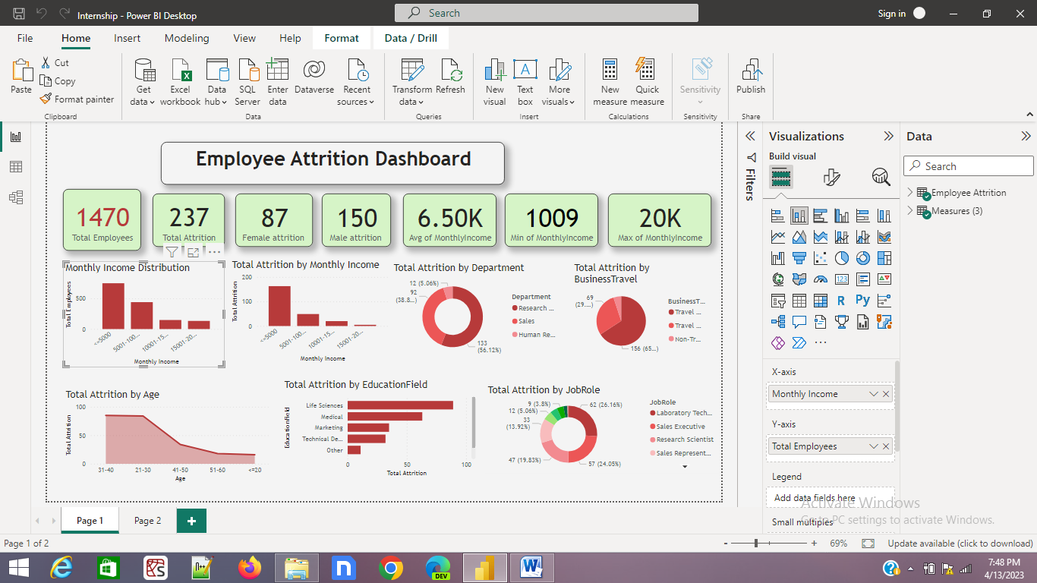

**CHALLENGES AND OPPORTUNITIES**

Since this was my first experience of doing a completely self-paced internship the biggest challenge was to make a plan on how to execute the ideas. It was difficult for me to find suitable DAX functions to create measures. I referred websites to find the use of DAX functions to decide which one I have to use. Since the dataset provided contains huge volume of entries it was difficult to represent it in form of charts and diagrams. This problem was overcome by creating conditional columns to group the entries into different categories. I also found some contradictions while working on job satisfaction and attrition which I am still working on to find a solution.

The internship has given me a n opportunity to get familiar with an industry project on Power BI. It also gave me an exposure to the various options on creating dashboards through reference materials. Most importantly it increased my confidence to do an internship completely by myself.

**REFLECTIONS ON THE INTERNSHIP**

This internship was a great opportunity for me as it opened a new door towards industry experience. It has given me a wonderful experience of a project done completely with my effort. It helped me to gather much information through my research. It provided me an exposure to the dashboard creation and analysis.

**CONCLUSION**

The project has given many insights on employee attrition and performance analysis. The various factors such as income distance from home, age salary hike etc. affect the employee attrition and performance. The dashboard gives an analysis on various factors affecting attrition.

**Link to executable file**

https://drive.google.com/file/d/14Hgb5p79HKkkiAlAofqqutzV3zRlfqfC/view?usp=sharing